Dhani App sentiment report

# Overall Summary

* App name: Dhani
* Number of reviews analyzed is 63,027
* Total number of reviews after cleaning the data is 22,840
* Timeline of reviews: 21 September,2020 to 21 January,2021 (122 days)

## Comparison of Aspects depending on how many numbers of people are writing about the aspect.

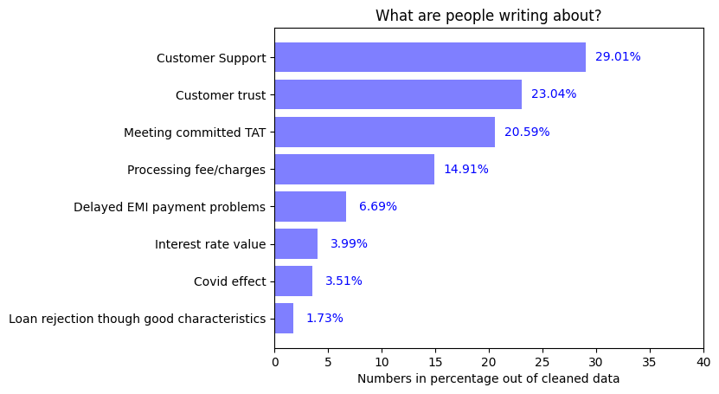

## Comparison of Aspects depending upon average rating given by users:

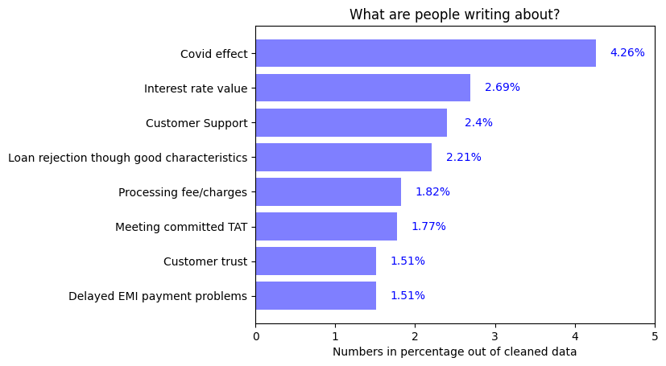

### Inference:

1. Large number of people are writing about meeting committed TAT and Customer support and trust so these are important points from users’ perspective
2. Reasonable number of people have written about Customer trust and it has very low average rating. Possible reasons for this are:
   1. Spam messages
   2. Not getting loan at all
   3. False promises
   4. App not working as expected

# 1.Appropriate Interest rate

* Percentage of people writing about this topic is 3.99%
* Average rating given by users for this aspect is 2.69 out of 5
* 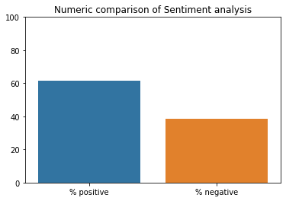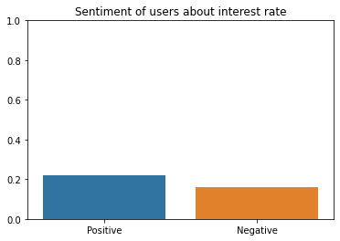Sentiment Analysis:

Figure 2: This shows how many people are positive or negative about this aspect

Figure 1: This shows Intensity of negativity or positivity of sentiments

### Inference:

1. People are more positive than negative about interest rate
2. Large number of people are Positive about interest rate and it matches the industry standards
3. As compared to 4 months analysis users were happier about interest rate previously but their sentiment became more negative during the latest 4 months.
4. Clearly, rating given by users has depreciated for the last 4 months as compared to average rating for the 1 year

Further Insights:

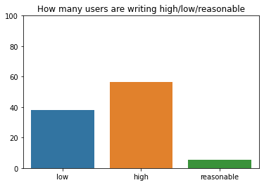

Blue= People saying interest rate is low =37.99%

Orange= People saying interest rate is high=56.56%

Green= People saying interest rate is reasonable=5.53%

We see that the app has increased their interest rate during the last 4 months compared to industry standard

# 2.Delayed payments of EMI

* Percentage of people writing about this topic is 6.69%

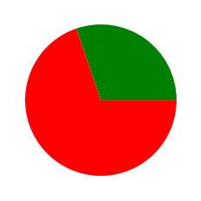

* Average rating given by users is 1.51 out of 5
* 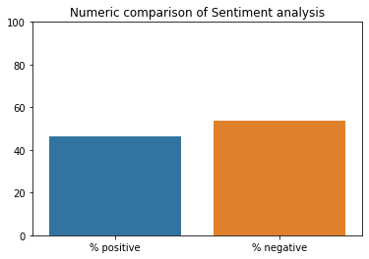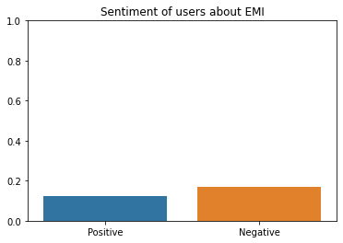Sentiment Analysis:

Figure 2: This shows how many people are positive or negative about this aspect

Figure 1: This shows Intensity of negativity or positivity of sentiments

### Inference

1. People are equally positive and negative about the EMI
2. Almost 60% number of people are writing with negative sentiment
3. We see that the performance of app on this aspect has also depreciated in the last 4 months as we compare average rating and % negative count for 1 year and 4-month data
4. Possible reasons:
   1. If user is late to pay an instalment then she/he is unable to get loan again
   2. Customers are not happy about EMI payment service in app
   3. If delay if EMI payment, app didn’t give NOC certificate
   4. Even if EMI is paid or automatically debited the app is not showing the update instead it is showing as outstanding loan status

# 3. Loan rejection though good characteristics

* Percentage of people writing about this topic is 1.73%



* Average rating given by users is 2.21 out of 5
* 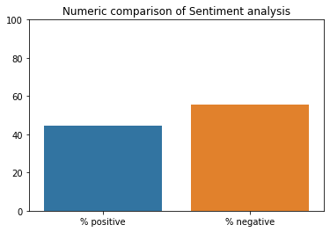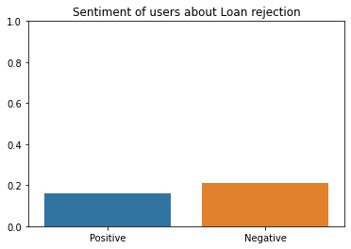Sentiment analysis:

Figure 2: This shows how many people are positive or negative about this aspect

Figure 1: This shows Intensity of negativity or positivity of sentiments

### Inference:

1. users are writing more negative than positive for this aspect
2. Slightly a greater number of users are writing negative reviews about loan rejection
3. But, very less that is only 1.7 % users are writing about this topic

# 4. Customer queries / grievances support services:

* Percentage of users writing about this topic is 29.01%



* Average rating for Customer support is 2.40 out of 5
* 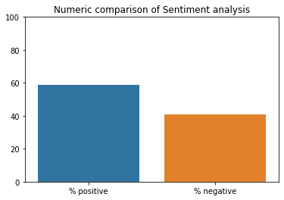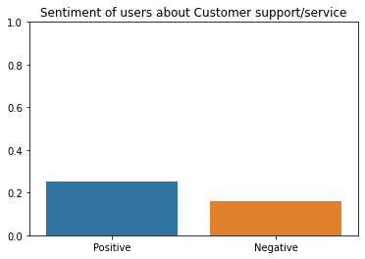Sentiment Analysis:

Figure 2: This shows how many people are positive or negative about this aspect

Figure 1: This shows Intensity of negativity or positivity of sentiments

### Inference:

1. Users are more positive about Customer support
2. Almost 30% of users are writing about this aspect

# 5.Processing Fee/ Extra Charges:

* Percentage of People writing about this topic is 14.91%



* Average rating for this topic = 1.82 out of 5
* 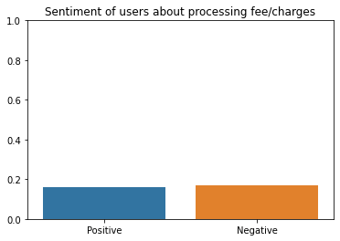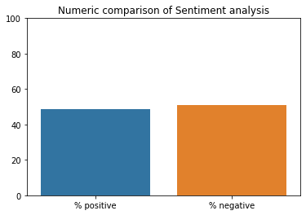Sentiment:

Figure 2: This shows how many people are positive or negative about this aspect

Figure 1: This shows Intensity of negativity or positivity of sentiments

### Inference:

1. Users are not satisfied about processing fee/charges
2. More than 50% of users are unhappy about extra charges
3. The view of users about this aspect has become more negative during the last four months as compared to 1year data
4. Users are unhappy about:
   1. Overdue charges
   2. Charges if the check bounces
   3. Charges if the EMI payment is delayed by the users

# 6. Loan disbursal to customer meeting the committed TAT

* Percentage of users writing about this topic is 20.59%



* Average rating by users is 1.77 out of 5
* 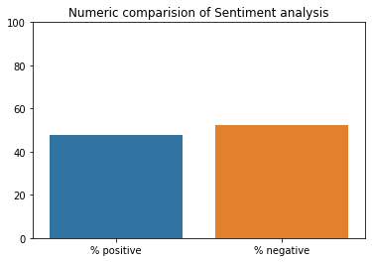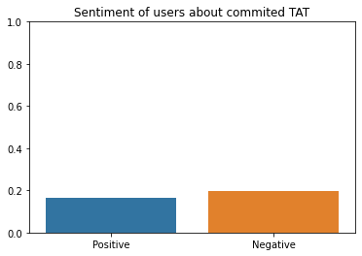Sentiment:

Figure 2: This shows how many people are positive or negative about this aspect

Figure 1: This shows Intensity of negativity or positivity of sentiments

### Inference:

1. Sentiment of users about TAT is mostly negative
2. Large number of users are writing about this topic and the cumulative sentiment is negative
3. Almost 20% of users have written about this aspect

# 7.Trust / legal/ fraud issues with app

* Percentage of users writing about this topic is 23.04%

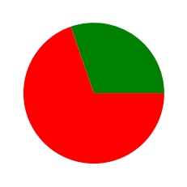

* Average rating by these users is 1.51 out of 5
* 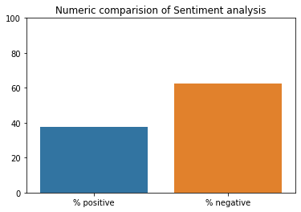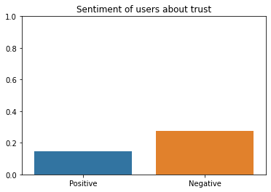Sentiment:

Figure 2: This shows how many people are positive or negative about this aspect

Figure 1: This shows Intensity of negativity or positivity of sentiments

### Inference:

### About 23% of users have written about trust on the app

### Out of which 60% users have suspicious view about the app while others are satisfied of its services

# 8.Covid-19 effect

* Percentage of users writing about this topic is 3.51%

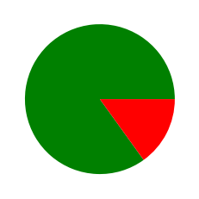

* Average rating by these users = 4.26 of 5
* 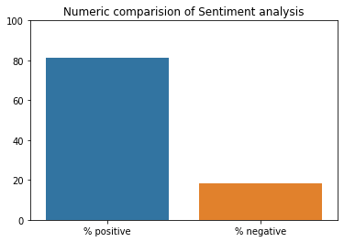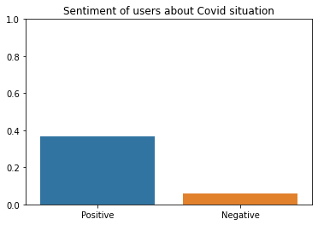Sentiment analysis:

Figure 2: This shows how many people are positive or negative about this aspect

Figure 1: This shows Intensity of negativity or positivity of sentiments

### Inference:

1. The services given by the app in covid-19 pandemic times are satisfactory completely
2. As, more than 80% of users are unhappy about the service provided in this period

### 